PRACTICAL NO. 3
Aim: To implement linear and binary search algorithm on a list
- Aim: Linear Search.
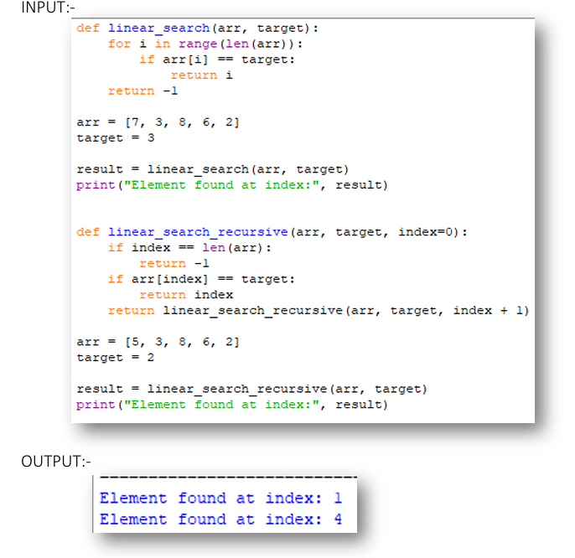

- Aim: Binary Search.
